April Is MODern Month in Houston and Texas
2017 MODern Month Events- Houston Area
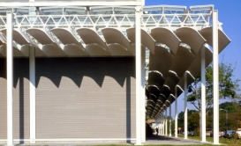
Walking Tour- American Institute of Architects- ArCH
April 1, 10 AM, Montrose- St. Thomas, Rothko, Menil, more
1520 Sul Ross St., Houston, TX, 77006 713-520-0155
Admission Fee, Reservation Recommended
https://aiahouston.org/v/event-detail/Montrose-Walking-Tour/pg/

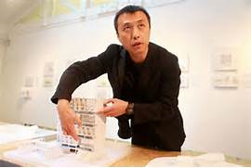
Lecture- Rice School of Architecture
April 3, 5:30 PM, Li Hu of Open Architecture
Project Open Spaces Balancing Man Made & Nature
Anderson Hall, Farish Gallery 713-348-4864
Rice University, 6100 Main Street, 77005 Admission Free
http://www.arch.rice.edu/Event.aspx?EventRecord=32203
http://parking.rice.edu

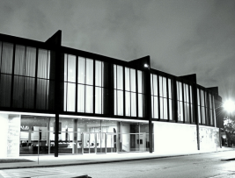
Tour- MFAH Law Building Highlights
April 4, 7, 11, 14, 18, 21, 25, 1 PM, Mies Van der Rohe, Kenneth Franzheim & W. W. Watkins Designed Building
1001 Bissonnet St. Houston, TX, 77005 Law Building
Free with General Admission 713-639-7300
https://www.mfah.org/calendar/treasures-caroline-wiess-law-building

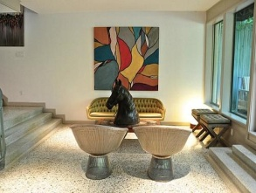
Sip & Shop- Modern Month Kick-off at Native Citizen
April 4, 7 - 9 PM, This shop features 20th century modern furniture, re-purposed industrial, art, and more.
2311 Dunlavy St., Houston, TX, 77006 713-527-8088
Suggested Donation www.nativecitizen.com

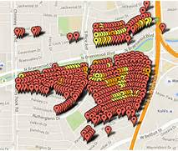 500 x 420 - swamplot.com
Symposium- AIA Urban Design Committee- Flooding & Storm Surge April 5, 5:30 PM
Brown Convention Center, 1001 Avenida de las Americas, Room 371, Houston, TX, 77010 713-520-0155
Admission Free, Registration Required
https://aiahouston.org/v/event-detail/flooding-and-storm-surg-symposium/10h/

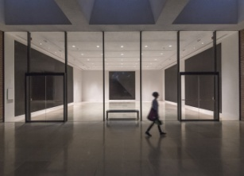
Art Exhibition- Rice Gallery Glossy & Flat Black Squares- Sol LeWitt, Pioneer of Conceptual Art
Open thru May 14, (closed Mondays), Rare site-specific art gallery will close after this exhibit. Sewall Hall,
Rice University, 6100 Main St., 77005 713-348-6069
Admission Free www.ricegallery.org/sol-lewitt-1/

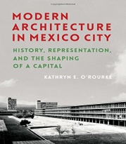
Book Discussion and Signing- Brazos Bookstore
April 7, 7 PM, Modern Architecture in Mexico City by Kathryn E. O’Rourke
2421 Bissonnet St. Houston, TX, 77005 713-523-0701
Admission Free www.brazosbookstore.com/

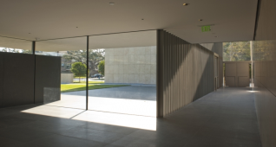
Architecture Tour- The Asia Society
April 8, 12 Noon, Guided Tour of Yoshio Taniguchi’s first freestanding USA Building
1370 Southmore Blvd., Houston, TX, 77004 713-496-9901
Admission Fee www.asiasociety.org/texas

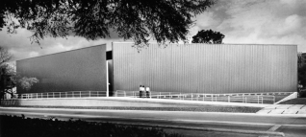
Walking Tour- Preservation Houston
April 9, 2 PM, Main Street & Montrose Boulevard
Explore the history and development of the MFAH area.
Meet at Jung Center, 5200 Montrose, 77006 713-510-3990
Admission Fee http://preservationhouston.org/

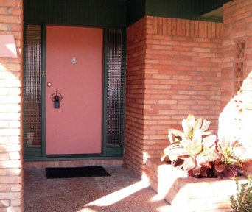
Open House- Mod of the Month
Details to be announced
Help find a new preservation-minded owner for an endangered modern property. Admission Free http://www.houstonmod.org/

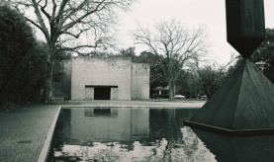
Architecture, Art & Music- Rothko Chapel
April 20, 7 PM, Adam Tendler, piano concert, Modern music evangelist fuses music and physical space.
3900 Yaupon St., Houston, TX, 77006
Suggested Donation, 713-524-9839
www.rothkochapel.org

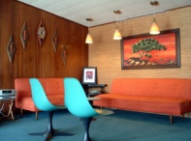
Cocktail Party- Heritage Society SIP
See Interesting Places- Glenbrook Valley
April 20, 6 PM, Visit a Houston Mod Preservation Award winning house. 713-655-1912
Admission Fee http://www.heritagesociety.org/

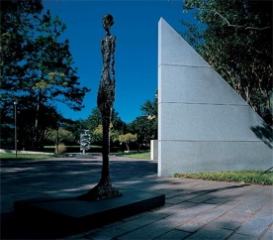
Walking Tour- American Institute of Architects- ArCH
April 29, 10 AM, Museum District Walking Tour
Montrose @ Bissonnet, Houston, TX, 77006 713-520-0155
Admission Fee, Reservation Recommended
https://aiahouston.org/v/event-detail/walking-Tour/pk/

________________________________________________________________________________________________________________________
Houston Mod established MODern Month in April 2010 to bring attention to the importance of protecting modern architecture and design in Houston and Texas. In 2011, Preservation Texas expanded the program to a state-wide focus.

